

NOVAC TECHNOLOGY SOLUTIONS

User Manual

Document Version No.: 1.00

Revision History
Version No | Reason For Changes | Author | Approver
0.01 | Draft | Ravi
1.00 | Reviewed & Approved the User Manual | Ravi | NIJANTHAN PL

Table of Contents
1. Introduction 4

2. Ri Payment Search 4

Introduction

The document is prepared to understand the reports generated in ZIVA application. This document is being prepared in reference to,
- Guidelines, circulars, instructions and directions released from time to time by Philippines Insurance council.

Functional Overview

System should have a payment screen to pay the RI-Facultative / Co-Insurer premium to the respective Re-insurer / Co-Insurer.

RI Payment Search

The system should provide an option to pay the share premium to the respective RI-Facultative or Co-Insurer.
The system should also allow user to pay the share premiums for multiple policies to the corresponding Facultative Reinsurer or Co-Insurer in single transaction.

Search -> RI Payment Search
Screen Code: S0467

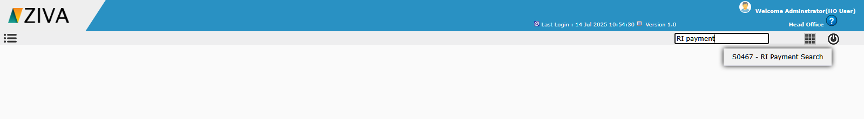

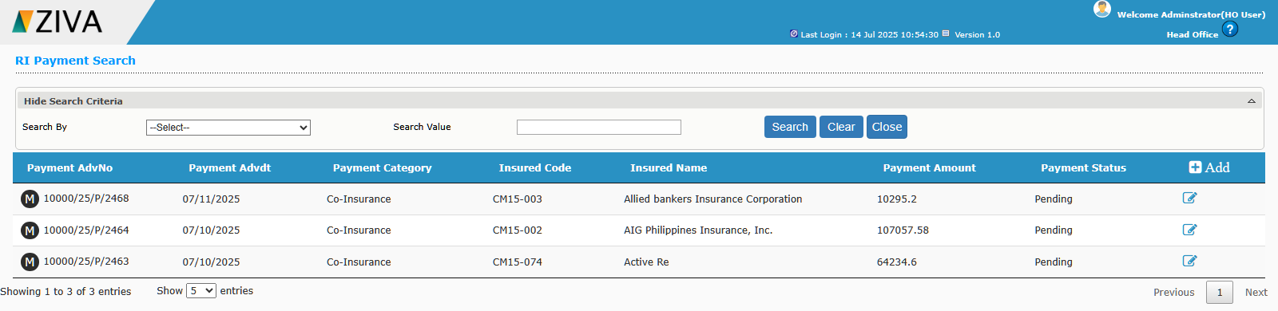
System should retrieve and display the saved payment records in the grid when opening the screen.
On clicking the “Add” button, system should redirect to RI-Facultative / Co-Insurance Payment Screen.

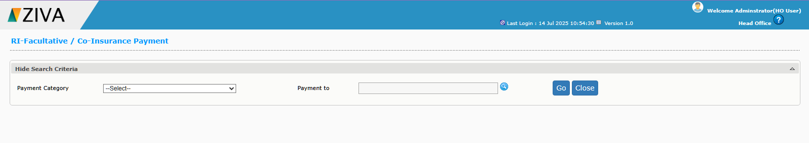
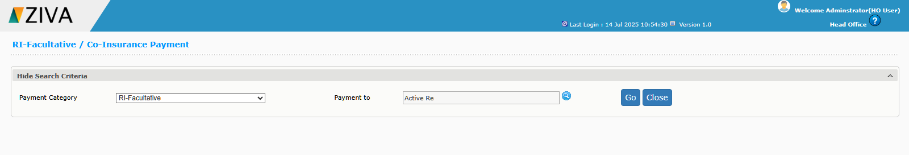

Enter all the required details and click the Go button. System move to RI-Facultative / Co-Insurance Payment Screen.

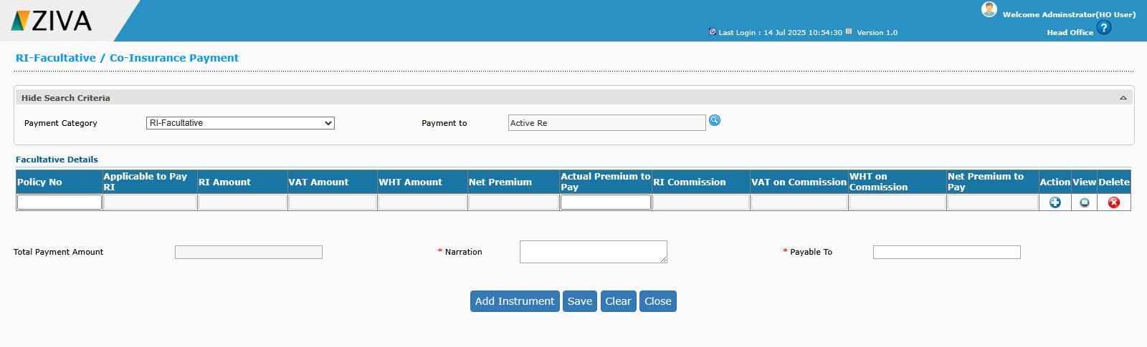

System should allow to select the multiple policy details against the corresponding RI-Facultative insurer (or) Co-Insurer to pay the share premium of multiple policies in the single payment similar to commission payment screen.
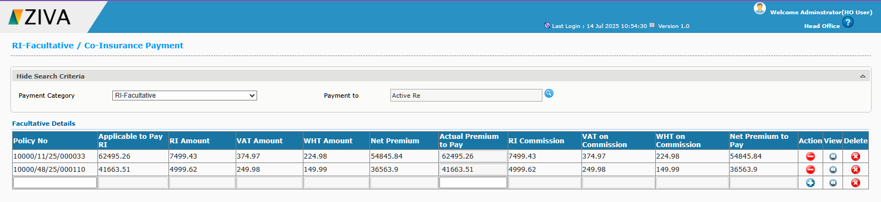

System should allow to select the multiple policy details against the corresponding RI-Facultative insurer (or) Co-Insurer to pay the share premium of multiple policies in the single payment similar to commission payment screen.

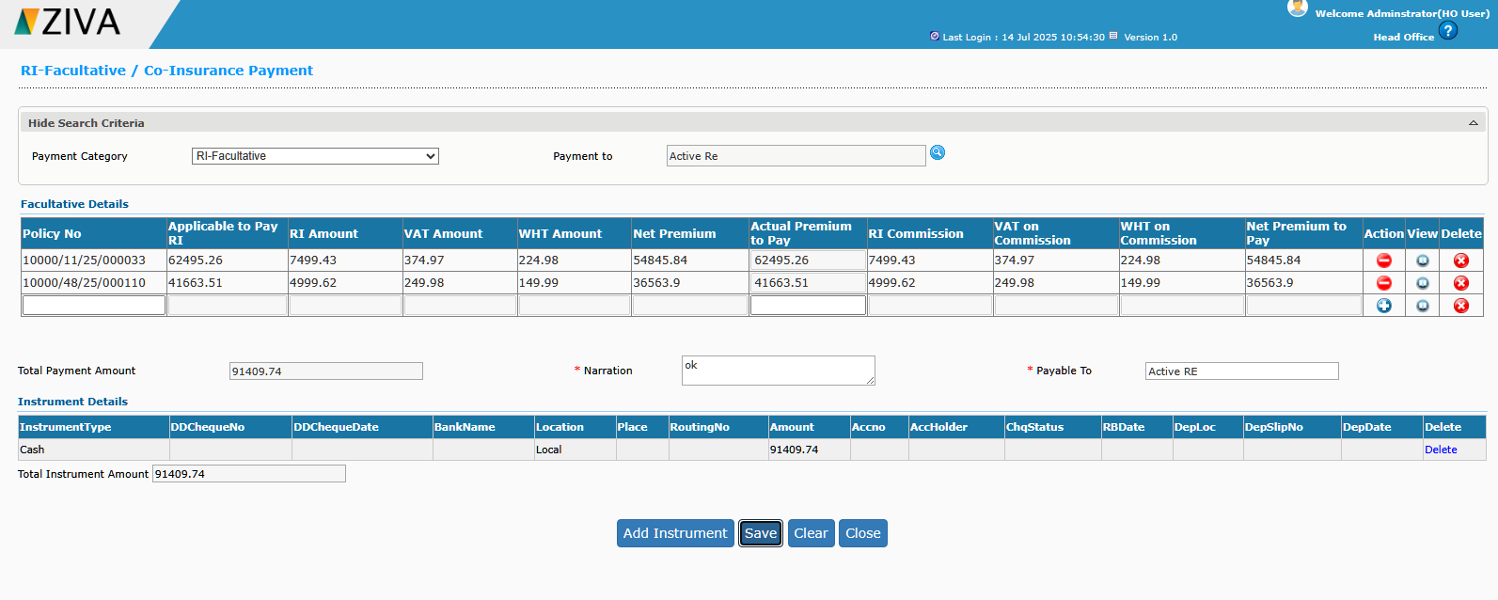

After added all records, then “Add instrument” and click “Save” button. Details will be saved, then clicking on the “Submit” system will pay the respective records.

